Shared User Configuration (Description)
The Citrix Receiver is used to access virtualized resources using a wide array of devices. The instructions below cover the installation and configuration of the Citrix Receiver on an Android device to access Baptist Health resources.

Downloading the Citrix Receiver (Android)
- Launch the Google Play Store
- Search for “Citrix Receiver”
- Install the application. Once installed you should have an icon appear that looks like:
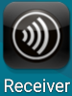

Configuring the Citrix Receiver (Android)
- Launch “Receiver”
- You will be presented with the following screen, select “Add Account”
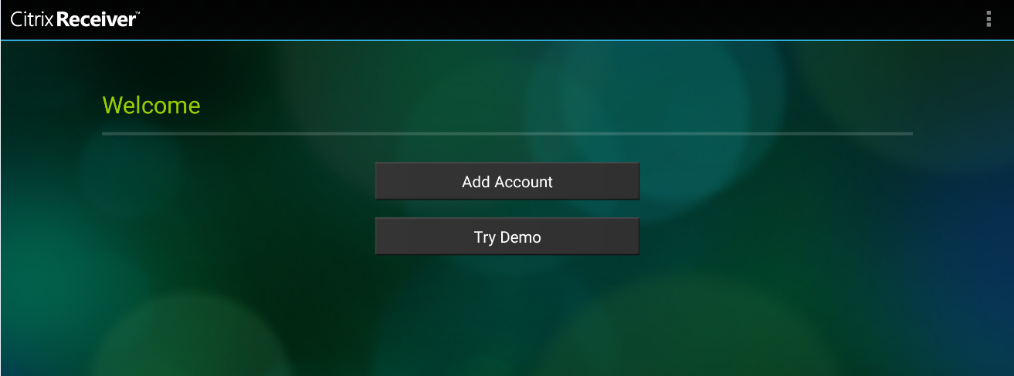
- Enter “connect.bhsi.com” (without quotes) in the Address field and click Next
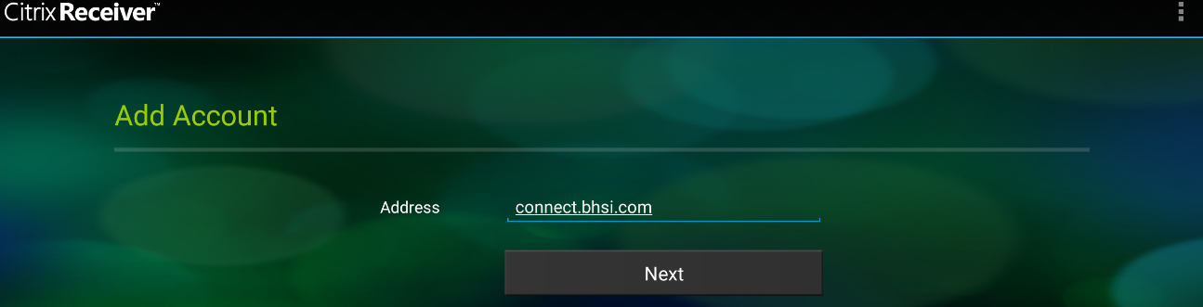

- Enter in the following information. The User Name and Password credentials are the same as your Windows credentials used when logging into a Baptist Health PC. Once complete click “Log On”
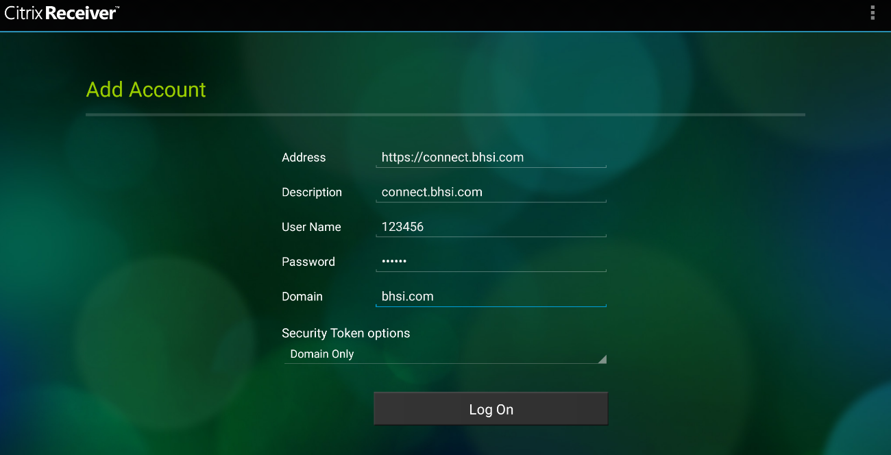

Personalizing Citrix Receiver (Android)
- Once you have logged in, you will be presented with the following screen
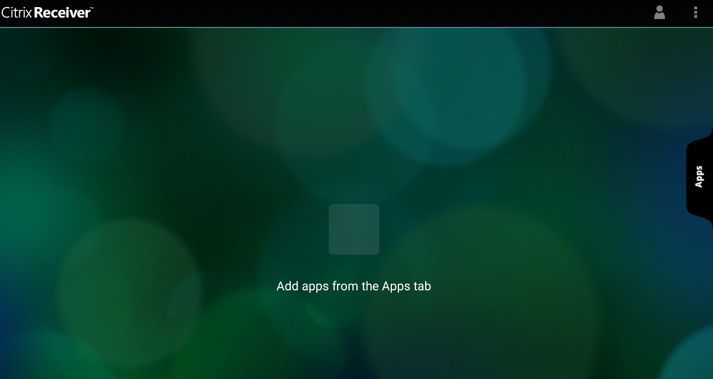
- Click “Apps” on the right to view the apps you have access to. From here, as you click on the apps they will move to your home screen where they can be launched.

- Should you want to remove an icon from your home page, tap and hold the icon. This will pop up an option to “Remove from Receiver Home”
